ISO 9000 Training and Implementation
Software Requirements Specification
For ISO 9000 Certification

Version 2.0

Revision History
Date | Version | Description | Author
19/Apr/03 | 1.0 | Software Requirements Specification: First Draft | Vikas, Raju, Yatin, Bhavana
28/Apr/03 | 2.0 | Software Requirements Specification: Final Draft | Vikas, Raju, Yatin, Bhavana

Table of Contents
1. Introduction 4
1.1 Purpose 4
1.2 Scope 4
1.2.1 Identification 4
1.2.2 System Overview 4
1.2.3 Document Overview 4
1.3 Definitions, Acronyms and Abbreviations 5
1.4 References 5
2. Overall Description 5
2.1 Product Perspective 5 2.2 Product Functions 6
2.3 User Characteristics 6
2.4 Constraints 6
2.5 Assumptions and Dependencies 6
2.6 Use Case Diagram for ITI software 7
3. Specific Requirements 8
3.1 External Interface Requirements 8
3.2 Function Requirements 8
3.2.1 Login 8
3.2.1.1 Brief Description 8
3.2.1.2 Flow of Events 8
3.2.1.3 Precondition 8
3.2.1.4. Postcondition 8
3.2.2 Select Type of Quiz 9
3.2.2.1 Brief Description 9
3.2.2.2 Flow of Events 9
3.2.2.3 Precondition 9
3.2.2.4. Postcondition 9
3.2.3 Manage System User Info 9
3.2.3.1 Brief Description 10
3.2.3.2 Flow of Events 10
3.2.3.3 Precondition 10
3.2.3.4. Postcondition 10
3.2.1 Create Question Groups 10
3.2.1.1 Brief Description 10
3.2.1.2 Flow of Events 10
3.2.1.3 Precondition 10
3.2.1.4. Postcondition 11
3.3 Usability 11
3.3.1 Online Tutorials for Training the employees of the company 11
3.3.2 Graphical analysis of the users performance and the company’s performance towards achieving ISO certification 11
3.3.3 Quizzing Managers and Supervisors 11
3.4 Reliability 11
3.5 Performance 11
3.6 Design Constraints 12
3.7 Online User Documentation and Help System Requirements 12
3.8 Purchased Components 12
3.9 Interfaces 12
3.9.1 User Interfaces 12
3.10 Licensing Requirements 13
3.11 Legal, Copyright and Other Notices 13
3.12 Applicable Standards 13
Software Requirements Specification

Introduction
The Software Requirements Specification (SRS) for the product ISO 9000 Training and Implementation describes and specifies engineering and qualification requirements for the system to the best of our knowledge and belief.

Purpose
The SRS fully describes the external behavior of the ISO 9000 Training and Implementation. It also describes nonfunctional requirements, design constraints and other factors necessary to provide a complete and comprehensive description of the requirements for the software.

Scope
1.2.1- Identification
System Name: ISO 9000 Training and Implementation
System Abbreviation: ITI
System Version Number: 1.0
Project Office: Armand Resources
Project Manager: Vikas Salvi
Project Sponsor: V-Tech consultants, Honeywell
System Users: Managers, Consultants, Executives, and Supervisors
System Developer: V-Tech Software Solutions
Supporting Agencies: ISO Consultancy & Services

1.2.2- System Overview
The ITI is specialized software for a particular company. This is developed for working on intranet. This system need not be interfaced with any other applications, as it is independent of all the external factors. It has a database from which it accesses the quiz questions and sends them to the test taker based on his designation. For example, a Manager gets a different set when compared to a supervisor.
This software will also have a report generator and a result calculator for the quizzes. The Consultant, Executive and Management representative check the reports generated. The result calculator will calculate the score of the test taker who may be a manager or a supervisor and shows him his score.

1.2.3- Document Overview
This Software Requirements Specification (SRS) contains the requirements and detailed specifications for system development of ITI release 1.1.

Definitions, Acronyms and Abbreviations

Term | Meaning
1) ISO | International Organization for Standardization.
2) ITI | ISO 9000 Training and Implementation

References
1) www.iso.org
2) Praxiom Research group Limited. www.praxiom.com
3) Dr James Helm online notes.
4) Dr Dabney online notes.
5) Managing software requirements: A Unified Approach. Authors: Dean Leffingwell & Don Widrig

Overall Description

Product Perspective
This software is being developed to help the company to acquire ISO certification quickly and easily. This system is not a substitute for an ISO consultant but rather helps a consultant to implement ISO standards for a company. The system helps in reducing the consultation cost, which would increase the profit margin of the company. In the present competitive world ISO standards have become an almost universal business requirement, which many governments and customers are insisting now a days. This document will be useful during the development of future project tied to the functionalities implemented in the ITI Software.

Product Functions

Login
~
Select Quiz Type
~
Create Question Groups
~
Create Quiz Type
~
Online Grading Criteria
~
Add Images
~
Manage System User Info
~
Reports
~
Get Feedback

User Characteristics
The users have different views of the software. The manager gets feedback from the users for their suggestions whereas the consultant helps the system administrator to create quiz type and create work groups.

Constraints
- Simultaneous write access by more clients must be available.
- ITI software should be optimized for speed.
- The system must utilize existing operating environment.

Assumptions and Dependencies
Here we assume that there is a network of computers and that we have a consultant along with a system administrator to manage the system after the product is developed. We expect to use windows operating system on all machines. We expect to have a GUI Interface for the software.

Use-Case Diagram for ITI software

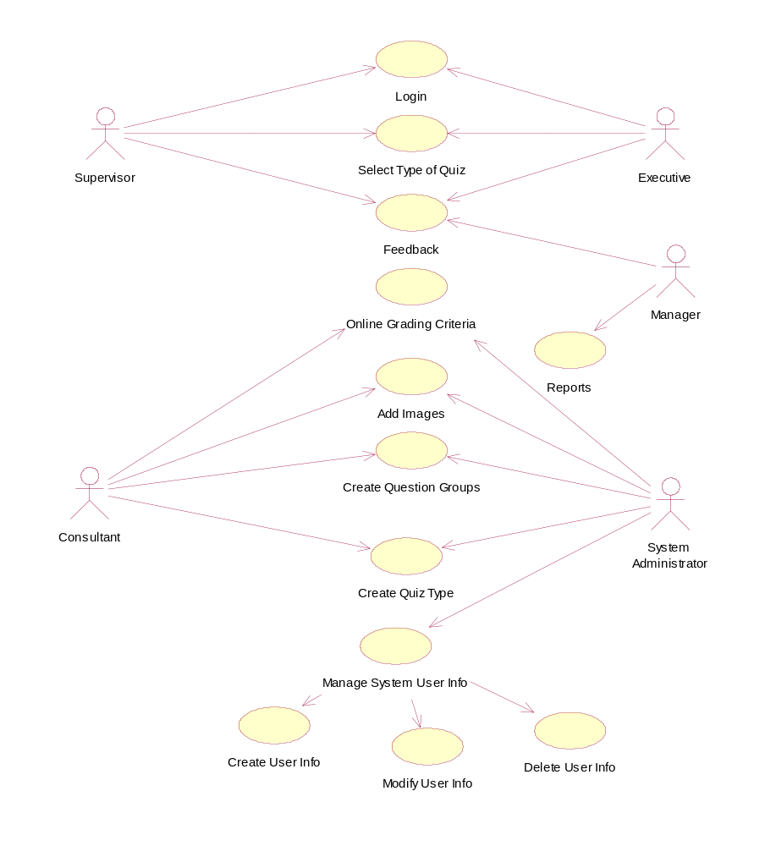

Specific Requirements

External Interface Requirements

NONE

Function Requirements

Login

Brief Description
This functionality is used for user authentication in the software. Depending on the type of user the functionality will decide view of the software. This is also an additional facility to prevent unauthorized access to the software.
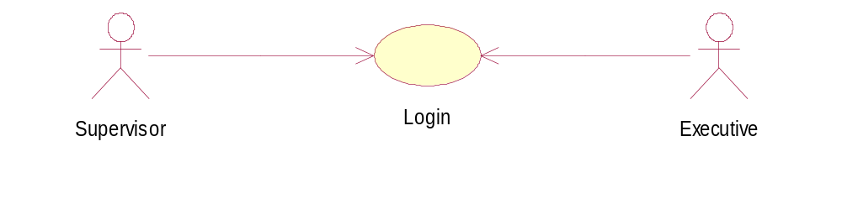

Flow of Events
- The user opens the application.
- The system prompts the user for username and password.
- The user enters the username and password.
- The system validates the user information.
- The system gives access to the user if user is authentic.

Precondition
  - The system is functional.
  - The user info is already present in the database.
  - The user enters his username and password.

PostCondition

The system allows access to the user.

Select Type of Quiz

Brief Description
The user selects the type of quiz using this functionality. The types of quizzes are: True/False, Multiple choices, Selection from a list, Numeric response.
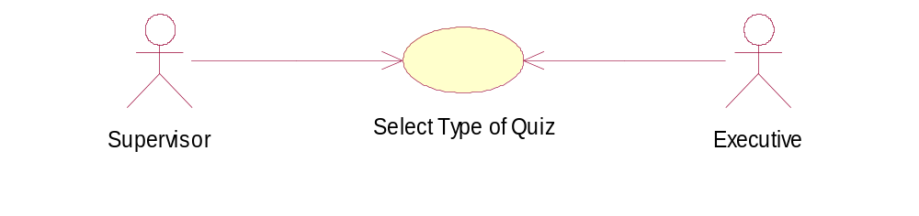

Flow of Events
- The user logs into the system.
- The system prompts the user for the type of quiz.
- The user selects the quiz type.
- The system reconfirms for users selection.

Precondition
  - The system is functional.
  - The system administrator has entered all the quiz types in the database.
  - The user has selected the select quiz type option.

PostCondition
The system starts the user selected quiz.

Manage system user Info

Brief Description
The types of users who access the system are: Manager, Supervisor, Consultant, Executive and System administrator. The system administrator manages the users information. The system administrator can create, modify and delete user information using this system functionality.

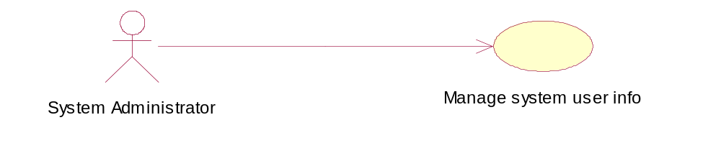

Flow of Events
- The system administrator logs into the system.
- The administrator selects manage system user info function.
- The system prompts for type of action to be performed.
- The system administrator selects the type of action to be performed.
- The system administrator logs out of the system.
- The system software makes necessary changes in the system.

Precondition
  - The system is functional.
  - The system administrator has entered into the system.
  - The user is present in the system.

PostCondition
The system software updates the users information in the system.

Create Question Groups

Brief Description
The system administration creates different question groups for different users of the system. The consultant being the main person for questions for the quiz provides questions to the system administrator.

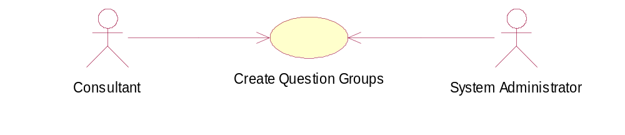

Flow of Events
1. The system administrator logs into the system.
2. The administrator selects creates question groups function.
3. The system prompts for create question groups.
4. The consultant gives the list of questions for different users of the system.
5. The system administrator creates the question groups given by the consultant.
6. The system software makes necessary changes in the system.

Precondition
- The system is functional.
- The system administrator has entered into the system.
- The consultant has given a list of questions and the user group it belongs to.

PostCondition
The system software updates the system database with different question groups.

Usability

Online Tutorials for training the employees of the company.
The software supports online tutorials for training the employees of the company. This requirement should have good user interface with easy accessibility for different users of the system.

Graphical analysis of the users performance and the company’s performance towards achieving the ISO certification
This is report that is generated by the software to keep a track of user performance. The report that is generated should be easy to understand and information should be conveyed properly.

Quizzing Managers and Supervisors.
The quizzing form should have a link to online help throughout his quizzing session. It should also have easy interface and practice sessions before the quiz begins.

Reliability

• Availability—The system should be available all the time for users to give online test.
• Accuracy— The software should be accurate enough so that the managers can keep a track of the user performance.
• Maximum Bugs or Defect Rate—The bugs per lines of code should be as low as possible.

Performance

Response time for a transaction (average – 5 Sec. , maximum - 20 Sec.)
Throughput (5-40 transactions per second)
Capacity (the system can accommodate 150 users at a given instance of time)
Degradation modes (degradation is not tolerated and just in case if there is any the session ends with rollback of the database and error detection.)

Design Constraints

- Server configuration
- PC with Pentium microprocessor 1.9 Ghz.
- 512 MB of RAM.
- Microsoft Windows NT 4.0.
- 52x CD-ROM drive.
- 16-bit color display.
- Windows- compatible sound card, headphones or speakers.
- NIC (Network interface card)
- Client configuration
- PC with Pentium microprocessor 400 Mhz.
- 128 MB of RAM.
- Microsoft Windows 95/98.
- 48x CD-ROM drive.
- 16-bit color display.
- Windows- compatible sound card, headphones or speakers.
- NIC (Network interface card)

On-line User Documentation and Help System Requirements

Requirement: - Online Tutorials for training the employees of the company. The software supports online tutorials for training the employees of the company. This requirement should have good user interface with easy accessibility for different users of the system.

Purchased Components

The software components used in the system is whole and sole property of the company and in no circumstances should be distributed for illegal use or even for sharing the system without prior permission of the system designer.

Interfaces

User Interfaces

User interfaces with the system will be either HTML documentation (interface of system with the user) or in Visual Basic and other front ends used in designing the system (interface of the system with the administrator)

Licensing Requirements

This software may not be distributed to any other company or organization in any form as it is developed exclusively for training the employees of V-Tech software solutions. This software is meant only for testing, tutoring and giving reports. At any given time 150 users may simultaneously give the test. This software is developed exclusively for V-Tech software solutions and so the user need not pay anything for usage. There is no product key associated with the product. A person external to the firm cannot access the software and is not to be allowed to access it in any form.

Legal, Copyright, and Other Notices

The system should have a copyright so that its not unlawfully used by other companies. The logo of the company should be embedded in each and every form of the system.

Applicable Standards
The system must comply with existing standards (Java, TCP/IP, LAN etc.).
The company has its own ISO consultant helping the company in achieving ISO certification. This makes the company much more aware towards importance of quality.

